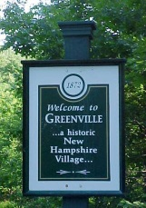

TOWN OF GREENVILLE, NEW HAMPSHIRE
PLANNING BOARD
NOTICE OF PUBLIC HEARING
ADOPTION OF AMENDMENTS TO THE MASTER PLAN

Pursuant to RSA 674:4 and 675:6, the Greenville Planning Board will hold a public hearing on Thursday, January 11, 2018 at 7:00 pm in the Town Hall Meeting Room, Chamberlin Street, Greenville, NH on a proposed rewrite of the Town of Greenville’s Master Plan.

A full copy of the text of the proposed rewrite of the Master Plan is available for review in the Board of Selectmen’s office during regular business hours.

All interested parties are encouraged to attend.

GREENVILLE PLANNING BOARD
Edward White, Chairman

